1. PROJECT DESCRIPTION : "ART GALLERY"

On line art gallery. In this we have added the details of artists.
We can upload and download the new arts. Payment gate way added to receive the payments.
We have added the blogs so that user can comments on the pictures and share the ideas about the title.
In this we have collected various arts of the artists from internet and other sources. We have also designed the template that represent the overall flow of the gallery maintained at the run time. We have added the uploading feature of the php that uploads the images and arts of the artists on line .
This site integrates the two parts first part is admin section that allow addition and deletion of the users who can view the arts and download them. Admin section have also added features to upload images and list the arts that can be modified or deleted.
Customer can also register online and they can browse art works that are arranged in different categories scientifically. Each Customer can create their own gallery to see his favorite art works with out much difficult. And each user has the right to purchase an art work using the integrated payment gateway and participate in auction by submitting their bids.Qualified bidder should remit the amount using payment gateway and after each valid payment the art work will be shipped within some days.
This application helps the end-users to search their arts and paintings and they can place order for the selected pieces. The end-user can also get the information about the art exhibition and the respective address, so, that they can visit to those exhibitions.
Art Gallery brings you an opportunity to view online art exhibitions at our Online Art Gallery we bring you details of all art exhibitions held in the past and the forthcoming show. The Online Art Gallery is updated daily, so the user can view and buy the latest collection of contemporary art online from anywhere in the world. You can view and buy the latest Indian contemporary art collection available at their exhibitions and also at their online gallery.

2. COMPONENTS OF THE PROJECTS

2.1 How to Login

In this module, the user will enter his username and password to view and give some comments on specific blogs and also reply can be made. There will be 3 types of users
Administrator/Students/Customer

2.2 How to be a member of blog site

In this site, the candidate can join the site ,if he is not a member yet by pressing new user link .User should provide some details that are asked to join.

2.3 How to search the blogs

Any blog can be searched by giving and selecting the topic and the title of the blog

2.4 How to give the comments

Select the given blog and then go the the comment option and give the comment.

2.5 To give the reply on a blog

Select the blog and go to the reply option and do the reply

3. REQUIREMENT ANALYSIS

3.1 Hardware Requirements

Number | Description
1 | Pentium 4 ,WIN xp/Linux
2 | 256 MB RAM

3.2 Software Requirements

Number | Description
1 | Windows XP –SP2
2 | Php 5.1
3 | MySql
4 | IIS server/ WAMP
5 | HTML/Dhtml/Ajax/JavaScript

4. MODULES

4.1 Login Module –In this module user can enter the site by providing username and password and start blogging.

4.2 Admin Module – Can upload new arts of the artists.

4.3 Join Module – In this module user can become a part of the site by providing some necessary information for example firstname , lastname ,password ,confirmation password ,email and other details .

4.4 Blog Module – In this User can create his own blog using the various topic options eg. Sports , politics etc .User also provides the title of the blog.

4.5 Search – In this user can search for the existing blog created already by the others.User chooses the category and enters the title . Then he presses the search blog button .All the matched enteries from the database are displayed.

4.6 Reply – User views the already existing blogs and then replies it to the corresponding sender.

4.7 Administrator – Can add modify delete the users employee.

5. INTRODUCTION TO TOOLS
FRONT-END/BACK-END
Front-End: Web Pages using PHP, HTML ,JavaScript and Net Beans
Back-End: MYSQL

5.1 Front End:

- HTML/CSS –The are used to generate web page . HTML, an initialism of Hypertext Markup Language, and CSS, Cascading stylesheet is the predominant markup language and style sheets for web pages. They provide a means to describe the structure of text-based information in a document — by denoting certain text as headings, paragraphs, lists, styles and so on.

- JAVASCRIPT – It is used for checking User information before sending to server .JavaScript is a scripting language most often used for client-side web development. It is a dynamic, weakly typed, prototype-based language with first-class functions. Currently, "JavaScript" is an implementation of the ECMAScript standard.

5.2 Backend:

- PHP:- Php is a technology that lets you mix regular, static HTML with dynamically-generated HTML. Many Web pages that are built by CGI programs are mostly static, with the dynamic part limited to a few small locations. But most CGI variations, including servlets, make you generate the entire page via your program, even though most of it is always the same.

- IIS SERVER /WAMP- Apache is a web container, or application server developed at the Apache Software Foundation (ASF).It adds tools for configuration and management but can also be configured by editing configuration files that are normally XML-formatted. Appache includes its own internal HTTP server.

5.3 Platform

The Blog everything is targeted at Microsoft Windows platform .It can be used with other platforms but not is yet tested on other platform such as linux and Vista.
6. Why PHP?

PHP is a widely used, general-purpose scripting language that was originally designed for web development, to produce dynamic web pages. It can be embedded into HTML and generally runs on a web server, which needs to be configured to process PHP code and create web page content from it. It can be deployed on most web servers and on almost every operating system and platform free of charge. PHP is installed on over 20 million websites and 1 million web servers. PHP was originally created by Rasmus Lerdorf in 1995 and has been in continuous development ever since. The main implementation of PHP is now produced by The PHP Group and serves as the de facto standard for PHP as there is no formal specification. PHP is free software released under the PHP License, which is incompatible with the GNU General Public License (GPL) because of restrictions on the use of the term PHP.
PHP has evolved to include a command line interface capability and can also be used in standalone graphical applications.

6.1 History
Rasmus Lerdorf, who wrote the original Common Gateway Interface binaries, Zeev Suraski, who rewrote the parser that formed PHP 3
PHP originally stood for Personal Home Page. It began in 1994 as a set of Common Gateway Interface binaries written in the C programming language by the Danish/Greenlandic programmer Rasmus Lerdorf. Lerdorf initially created these Personal Home Page Tools to replace a small set of Perl scripts he had been using to maintain his personal homepage. The tools were used to perform tasks such as displaying his résumé and recording how much traffic his page was receiving. He combined these binaries with his Form Interpreter to create PHP/FI, which had more functionality. PHP/FI included a larger implementation for the C programming language and could communicate with databases, enabling the building of simple, dynamic web applications. Lerdorf released PHP publicly on June 8, 1995 to accelerate bug location and improve the code. This release was named PHP version 2 and already had the basic functionality that PHP has today. This included Perl-like variables, form handling, and the ability to embed HTML. The syntax was similar to Perl but was more limited, simpler, and less consistent.
Zeev Suraski and Andi Gutmans, two developers at the Technion IIT, rewrote the parser in 1997 and formed the base of PHP 3, changing the language's name to the recursive initialism PHP: Hypertext Preprocessor. The development team officially released PHP/FI 2 in November 1997 after months of beta testing. Afterwards, public testing of PHP 3 began, and the official launch came in June 1998. Suraski and Gutmans then started a new rewrite of PHP's core, producing the Zend Engine in 1999. They also founded Zend Technologies in Ramat Gan, Israel
On May 22, 2000, PHP 4, powered by the Zend Engine 1.0, was released. As of August, 2008 this branch is up to version 4.4.9. PHP 4 is no longer under development nor will any security updates be released. On July 13, 2004, PHP 5 was released, powered by the new Zend Engine II. PHP 5 included new features such as improved support for object-oriented programming, the PHP Data Objects extension (which defines a lightweight and consistent interface for accessing databases), and numerous performance enhancements. In 2008, PHP 5 became the only stable version under development. Late static binding has been missing from PHP and has been added in version 5.3. PHP 6 is under development alongside PHP 5. Major changes include the removal of register_globals, magic quotes, and safe mode. The reason for the removals was that register_globals had given way to security holes, and magic quotes had an unpredictable nature, and was best avoided. Instead, to escape characters, magic quotes may be substituted with the addslashes() function, or more appropriately an escape mechanism specific to the database vendor itself like mysql_real_escape_string() for MySQL. Functions that will be removed in PHP 6 have been deprecated in PHP 5.3 and will produce a warning if used.
Many high-profile open-source projects ceased to support PHP 4 in new code as of February 5, 2008, because of the GoPHP5 initiative, provided by a consortium of PHP developers promoting the transition from PHP 4 to PHP 5.
PHP currently does not have native support for Unicode or multibyte strings; Unicode support will be included in PHP 6 and will allow strings as well as class, method and function names to contain non-ASCII characters.
It runs in both 32-bit and 64-bit environments, but on Windows the only official distribution is 32-bit, requiring Windows 32-bit compatibility mode to be enabled while using IIS in a 64-bit Windows environment. As of PHP 5.3.0, experimental x64 bit versions are available.

6.2

Usage
PHP is a general-purpose scripting language that is especially suited for web development. PHP generally runs on a web server. Any PHP code in a requested file is executed by the PHP runtime, usually to create dynamic web page content. It can also be used for command-line scripting and client-side GUI applications. PHP can be deployed on most web servers, many operating systems and platforms, and can be used with many relational database management systems. It is available free of charge, and the PHP Group provides the complete source code for users to build, customize and extend for their own use.
PHP primarily acts as a filter,] taking input from a file or stream containing text and/or PHP instructions and outputs another stream of data; most commonly the output will be HTML. Since PHP 4, the PHP parser compiles input to produce bytecode for processing by the Zend Engine, giving improved performance over its interpreter predecessor. Originally designed to create dynamic web pages, PHP now focuses mainly on server-side scripting,^{[33]} and it is similar to other server-side scripting languages that provide dynamic content from a web server to a client, such as Microsoft's Active Server Pages, Sun Microsystems' JavaServer Pages, and mod_perl. PHP has also attracted the development of many frameworks that provide building blocks and a design structure to promote rapid application development (RAD). Some of these include CakePHP, Symfony, CodeIgniter, and Zend Framework, offering features similar to other web application frameworks.
The LAMP and WAMP architectures have become popular in the web industry as a way of deploying web applications. PHP is commonly used as the P in this bundle alongside Linux, Apache and MySQL, although the P may also refer to Python or Perl.
As of April 2007, over 20 million Internet domains were hosted on servers with PHP installed, and mod_php was recorded as the most popular Apache module. Significant websites are written in PHP including the user-facing portion of Facebook, Wikipedia (MediaWiki), Yahoo!, MyYearbook,] Digg, Joomla, WordPress, YouTube, Drupal and Tagged.

6.3 Speed optimization
As with many scripting languages, PHP scripts are normally kept as human-readable source code, even on production web servers.^{[41]} In this case, PHP scripts will be compiled at runtime by the PHP engine, which increases their execution speed. PHP scripts are able to be compiled before runtime using PHP compilers as with other programming languages such as C (the language PHP and its extensions are written in).
Code optimizers aim to reduce the computational complexity of the compiled code by reducing its size and making other changes that can reduce the execution time with the overall goal of improving performance. The nature of the PHP compiler is such that there are often opportunities for code optimization, and an example of a code optimizer is the Zend Optimizer PHP extension.
Another approach for reducing overhead for high load PHP servers is using PHP accelerators. These can offer significant performance gains by caching the compiled form of a PHP script in shared memory to avoid the overhead of parsing and compiling the code every time the script runs. A PHP accelerator will be built into PHP 6.

6.4 Security
The National Vulnerability Database stores all vulnerabilities found in computer software. The overall proportion of PHP-related vulnerabilities on the database amounted to: 20% in 2004, 28% in 2005, 43% in 2006, 36% in 2007, and 35% in 2008.^{[44]} Most of these PHP-related vulnerabilities can be exploited remotely: they allow hackers to steal or destroy data from data sources linked to the webserver (such as an SQL database), send spam or contribute to DOS attacks using malware, which itself can be installed on the vulnerable servers.
These vulnerabilities are caused mostly by not following best practice programming rules: technical security flaws of the language itself or of its core libraries are not frequent (23 in 2008, about 1% of the total). Recognizing that programmers cannot be trusted, some languages include taint checking to detect automatically the lack of input validation which induces many issues. Such a feature is being developed for PHP, but its inclusion in a release has been rejected several times in the past.
Hosting PHP applications on a server requires a careful and constant attention to deal with these security risks. There are advanced protection patches such as Suhosin and Hardening-Patch, especially designed for web hosting environments. Installing PHP as a CGI binary rather than as an Apache module is the preferred method for added security.

6.5 Syntax
Syntax-highlighted PHP code embedded within HTML
PHP only parses code within its delimiters. Anything outside its delimiters is sent directly to the output and is not processed by PHP. The most common delimiters are <?php to open and ?> to close PHP sections. <script language="php"> and </script> delimiters are also available, as are the shortened forms <? or <?= (which is used to echo back a string or variable) and ?> as well as ASP-style short forms <% or <%= and %>. While short delimiters are used, they make script files less portable as their purpose can be disabled in the PHP configuration, and so they are discouraged. The purpose of all these delimiters is to separate PHP code from non-PHP code, including HTML.
The first form of delimiters, <?php and ?>, in XHTML and other XML documents, creates correctly formed XML 'processing instructions' This means that the resulting mixture of PHP code and other markup in the server-side file is well-formed XML.
Variables are prefixed with a dollar symbol and a type does not need to be specified in advance. Unlike function and class names, variable names are case sensitive. Both double-quoted ("") and heredoc strings allow the ability to embed a variable's value into the string. PHP treats newlines as whitespace in the manner of a free-form language (except when inside string quotes), and statements are terminated by a semicolon. PHP has three types of comment syntax: /* */ marks block and inline comments; // as well as # are used for one-line comments The echo statement is one of several facilities PHP provides to output text (e.g. to a web browser).
In terms of keywords and language syntax, PHP is similar to most high level languages that follow the C style syntax. If conditions, for and while loops, and function returns are similar in syntax to languages such as C, C++, Java and Perl.

6.6 Data types
PHP stores whole numbers in a platform-dependent range. This range is typically that of 32-bit signed integers. Unsigned integers are converted to signed values in certain situations; this behavior is different from other programming languages. Integer variables can be assigned using decimal (positive and negative), octal, and hexadecimal notations. Floating point numbers are also stored in a platform-specific range. They can be specified using floating point notation, or two forms of scientific notation. PHP has a native Boolean type that is similar to the native Boolean types in Java and C++. Using the Boolean type conversion rules, non-zero values are interpreted as true and zero as false, as in Perl and C++. The null data type represents a variable that has no value. The only value in the null data type is NULL. Variables of the "resource" type represent references to resources from external sources. These are typically created by functions from a particular extension, and can only be processed by functions from the same extension; examples include file, image, and database resources. Arrays can contain elements of any type that PHP can handle, including resources, objects, and even other arrays. Order is preserved in lists of values and in hashes with both keys and values, and the two can be intermingled. PHP also supports strings, which can be used with single quotes, double quotes, or heredoc syntax.
The Standard PHP Library (SPL) attempts to solve standard problems and implements efficient data access interfaces and classes.

6.7 Functions
PHP has hundreds of base functions and thousands more via extensions. These functions are well documented on the PHP site, however, the built-in library has a wide variety of naming conventions and inconsistencies. PHP currently has no functions for thread programming, although it does support multiprocess programming on POSIX systems.

Version 5.2 and Earlier
Functions are not first-class functions and can only be referenced by their name, directly or dynamically by a variable containing the name of the function. User-defined functions can be created at any time without being prototyped. Functions can be defined inside code blocks, permitting a run-time decision as to whether or not a function should be defined. Function calls must use parentheses, with the exception of zero argument class constructor functions called with the PHP new operator, where parentheses are optional. PHP supports quasi-anonymous functions through the create_function() function, although they are not true anonymous functions because anonymous functions are nameless, but functions can only be referenced by name, or indirectly through a variable $function_name();, in PHP.

Version 5.3 And Newer
PHP gained support for closures. True anonymous functions are supported using the following syntax:
function getAdder($x)
{
return function ($y) use ($x) {
return $x + $y;
};
}
$adder = getAdder(8);
echo $adder(2); // prints "10"
Here, getAdder() function creates a closure using parameter $x (keyword "use" forces getting variable from context), which takes additional argument $y and returns it to the caller. Such a function can be stored, given as the parameter to other functions, etc. For more details see Lambda functions and closures RFC.

6.8 Objects
Basic object-oriented programming functionality was added in PHP 3 and improved in PHP 4. Object handling was completely rewritten for PHP 5, expanding the feature set and enhancing performance.] In previous versions of PHP, objects were handled like primitive types. The drawback of this method was that the whole object was copied when a variable was assigned or passed as a parameter to a method. In the new approach, objects are referenced by handle, and not by value. PHP 5 introduced private and protected member variables and methods, along with abstract classes and final classes as well as abstract methods and final methods. It also introduced a standard way of declaring constructors and destructors, similar to that of other object-oriented languages such as C++, and a standard exception handling model. Furthermore, PHP 5 added interfaces and allowed for multiple interfaces to be implemented. There are special interfaces that allow objects to interact with the runtime system. Objects implementing ArrayAccess can be used with array syntax and objects implementing Iterator or IteratorAggregate can be used with the foreach language construct. There is no virtual table feature in the engine, so static variables are bound with a name instead of a reference at compile time.
If the developer creates a copy of an object using the reserved word clone, the Zend engine will check if a __clone() method has been defined or not. If not, it will call a default __clone() which will copy the object's properties. If a __clone() method is defined, then it will be responsible for setting the necessary properties in the created object. For convenience, the engine will supply a function that imports the properties of the source object, so that the programmer can start with a by-value replica of the source object and only override properties that need to be changed.

6.9 Resources
PHP includes free and open source libraries with the core build. PHP is a fundamentally Internet-aware system with modules built in for accessing FTP servers, many database servers, embedded SQL libraries such as embedded PostgreSQL, MySQL and SQLite, LDAP servers, and others. Many functions familiar to C programmers such as those in the stdio family are available in the standard PHP build. PHP has traditionally used features such as "magic_quotes_gpc" and "magic_quotes_runtime" which attempt to escape apostrophes (') and quotes (") in strings in the assumption that they will be used in databases, to prevent SQL injection attacks. This leads to confusion over which data is escaped and which is not, and to problems when data is not in fact used as input to a database and when the escaping used is not completely correct. To make code portable between servers which do and do not use magic quotes, developers can preface their code with a script to reverse the effect of magic quotes when it is applied.
PHP allows developers to write extensions in C to add functionality to the PHP language. These can then be compiled into PHP or loaded dynamically at runtime. Extensions have been written to add support for the Windows API, process management on Unix-like operating systems, multibyte strings (Unicode), cURL, and several popular compression formats. Some more unusual features include integration with Internet Relay Chat, dynamic generation of images and

7. MYSQL
MySQL (pronounced /maɪˌɛskjuːˈɛl/My S-Q-L, or "My sequel" /maɪˈsiːkwəl/) is a relational database management system (RDBMS) which has more than 6 million installations. MySQL stands for "My Structured Query Language". The program runs as a server providing multi-user access to a number of databases.
The project's source code is available under terms of the GNU General Public License, as well as under a variety of proprietary agreements. MySQL is owned and sponsored by a single for-profit firm, the Swedish company MySQL AB, now a subsidiary of Sun Microsystems, which holds the copyright to most of the codebase.
MySQL is commonly used by free software projects which require a full-featured database management system, such as WordPress, phpBB and other software built on the LAMP software stack. It is also used in very high-scale World Wide Web products including Google and Facebook.

7.1 Uses
MySQL is used in web applications and acts as the database component of the LAMP software stack. Its popularity for use with web applications is closely tied to the popularity of PHP, which is often combined with MySQL. Several high-traffic web sites (including Flickr, Facebook, Wikipedia, Google (though not for searches), Nokia, Auctionmarts and YouTube) use MySQL for data storage and logging of user data.

7.2 Platforms and interfaces
The MySQL Administrator in Linux
MySQL is written in C and C++. The SQL parser uses yacc and a home-brewed lexer, sql_lex.cc
MySQL works on many different system platforms, including AIX, BSDi, FreeBSD, HP-UX, i5/OS, Linux, Mac OS X, NetBSD, Novell NetWare, OpenBSD, OpenSolaris, eComStation, OS/2 Warp, QNX, IRIX, Solaris, Symbian, SunOS, SCO OpenServer, SCO UnixWare, Sanos, Tru64 and Microsoft Windows. A port of MySQL to OpenVMS is also available.
Libraries for accessing MySQL databases are available in all major programming languages with language-specific APIs. In addition, an ODBC interface called MyODBC allows additional programming languages that support the ODBC interface to communicate with a MySQL database, such as ASP or ColdFusion. The MySQL server and official libraries are mostly implemented in ANSI C/ANSI C++.
To administer MySQL databases one can use the included command-line tool (commands: mysql and mysqladmin). Also downloadable from the MySQL site are GUI administration tools: MySQL Administrator, MySQL Migration Toolkit and MySQL Query Browser. The GUI tools are now included in one package called MySQL GUI Tools.
In addition to the above-mentioned tools developed by MySQL AB, there are several other commercial and non-commercial tools available. Examples include Navicat Free Lite Edition or SQLyog Community Edition, they are free desktop based GUI tools, and phpMyAdmin, a free Web-based administration interface implemented in PHP.

7.3 Features
As of April 2009, MySQL offers MySQL 5.1 in two different variants: the MySQL Community Server and Enterprise Server. They have a common code base and include the following features:
- A broad subset of ANSI SQL 99, as well as extensions
- Cross-platform support
- Stored procedures
- Triggers
- Cursors
- Updatable Views
- True Varchar support
- INFORMATION_SCHEMA
- Strict mode
- X/Open XA distributed transaction processing (DTP) support; two phase commit as part of this, using Oracle's InnoDB engine
- Independent storage engines (MyISAM for read speed, InnoDB for transactions and referential integrity, MySQL Archive for storing historical data in little space)
- Transactions with the InnoDB, BDB and Cluster storage engines; savepoints with InnoDB
- SSL support
- Query caching
- Sub-SELECTs (i.e. nested SELECTs)
- Replication with one master per slave, many slaves per master, no automatic support for multiple masters per slave.
- Full-text indexing and searching using MyISAM engine
- Embedded database library
- Partial Unicode support (UTF-8 sequences longer than 3 bytes are not supported; UCS-2 encoded strings are also limited to the BMP)
- Partial ACID compliance (only full compliance when using the non-default storage engines InnoDB, BDB and Cluster.
The MySQL Enterprise Server is released once per month and the sources can be obtained either from MySQL's customer-only Enterprise site or from MySQL's Bazaar repository, both under the GPL license. The MySQL Community Server is published on an unspecified schedule under the GPL and contains all bug fixes that were shipped with the last MySQL Enterprise Server release. Binaries are no longer provided by MySQL for every release of the Community Server.
- Replication support (i.e. Master-Master Replication & Master-Slave Replication)

7.4 Distinguishing features
The following features are implemented by MySQL but not by some other RDBMS software:
- Multiple storage engines, allowing one to choose the one that is most effective for each table in the application (in MySQL 5.0, storage engines must be compiled in; in MySQL 5.1, storage engines can be dynamically loaded at run time):
  - Native storage engines (MyISAM, Falcon, Merge, Memory (heap), Federated, Archive, CSV, Blackhole, Cluster, Berkeley DB, EXAMPLE, and Maria)
  - Partner-developed storage engines (InnoDB, solidDB, NitroEDB, Infobright (formerly Brighthouse), Infobright (Open Source))
  - Community-developed storage engines (memcached, httpd, PBXT, Revision Engine)
  - Custom storage engines
- Commit grouping, gathering multiple transactions from multiple connections together to increase the number of commits per second.

7.5 Server compilation type
There are 3 types of MySQL Server Compilations for Enterprise and Community users:
- Standard: The MySQL-Standard binaries are recommended for most users, and include the InnoDB storage engine.
- Max: (not MaxDB, which is a cooperation with SAP AG) is mysqld-max Extended MySQL Server. The MySQL-Max binaries include additional features that may not have been as extensively tested or are not required for general usage.
- The MySQL-Debug binaries have been compiled with extra debug information, and are not intended for production use, because the included debugging code may cause reduced performance.
Beginning with MySQL 5.1, MySQL AB has stopped providing these different package variants. There will only be one MySQL server package, which includes a mysqld binary with all functionality and storage engines enabled. Instead of providing a separate debug package, a server binary with extended debugging information is also included in the standard package.

7.6 History
Milestones in MySQL development include:
- MySQL was originally developed by Michael Widenius and David Axmark beginning in 1994
- MySQL was first released internally on 23 May 1995
- Windows version was released on 8 January 1998 for Windows 95 and NT
- Version 3.23: beta from June 2000, production release January 2001
- Version 4.0: beta from August 2002, production release March 2003 (unions)
- Version 4.01: beta from August 2003, Jyoti adopts MySQL for database tracking
- Version 4.1: beta from June 2004, production release October 2004 (R-trees and B-trees, subqueries, prepared statements)
- Version 5.0: beta from March 2005, production release October 2005 (cursors, stored procedures, triggers, views, XA transactions)
- Sun Microsystems acquired MySQL AB on 26 February 2008.
- Version 5.1: production release 27 November 2008 (event scheduler, partitioning, plugin API, row-based replication, server log tables)

7.7 Future releases
The MySQL 6 roadmap outlines support for:
- Referential integrity and Foreign key support for all storage engines is targeted for release in MySQL 6.1 (although it has been present since version 3.23.44 for InnoDB).
- Support for supplementary Unicode characters, beyond the 65,536 characters of the Basic Multilingual Plane (BMP) is announced for MySQL 6.0.
- A new storage engine is also in the works, called Falcon. A preview of Falcon is available on MySQL's website.
Support for parallelization is also part of the roadmap for future versions.

7.8 Support and licensing
Via MySQL Enterprise MySQL AB offers support itself, including a 24/7 service with 30-minute response time, the support team has direct access to the developers as necessary to handle problems. In addition it hosts forums and mailing lists, employees and other users are often available in several IRC channels providing assistance.
Buyers of MySQL Enterprise have access to binaries and software that is certified for their particular operating system, and access to monthly binary updates with the latest bug fixes. Several levels of Enterprise membership are available, with varying response times and features ranging from how to and emergency support through server performance tuning and system architecture advice. The MySQL Network Monitoring and Advisory Service monitoring tool for database servers is available only to MySQL Enterprise customers.
MySQL Server is available as free software under the GNU General Public License (GPL), and the MySQL Enterprise subscriptions include a GPL version of the server, with a traditional proprietary version available on request at no additional cost for cases where the intended use is incompatible with the GPL.
Both the MySQL server software itself and the client libraries are distributed under a dual-licensing format. Users may choose the GPL, which MySQL has extended with a FLOSS License Exception. It allows Software licensed under other OSI-compliant Open Source licenses, which are not compatible to the GPL, to link against the MySQL client libraries.
Customers that do not wish to be bound to the terms of the GPL may choose to purchase a proprietary license.
Like many open-source programs, the name "MySQL" is trademarked and may only be used with the trademark holder's permission.
MySQL recently (2008) released version 5.1 with 20 known crashing and wrong result bugs in addition to the 35 present in version 5.0. Critical bugs sometimes do not get fixed for long periods of time. An example was a critical bug which was reported in 2003 and eventually patched six years later in an alpha release.
MySQL shows poor performance when used for data warehousing; this is partly due to inability to utilize multiple CPU cores for processing a single query.
MySQL does not offer a single table type ("storage engine") offering all features; the two most common types, MyISAM and InnoDB, do not completely overlap in their feature sets.
Previous versions of MySQL did not support many standard SQL features, with the manual claiming that they were unnecessary or would hurt performance. Even now, MySQL has many limitations that other RDBMS software (e.g. PostgreSQL) do not, such as the inability to refer to a temporary table twice in one query and extremely poor subselect performance.
The developer of the Federated Storage Engine states that "The Federated Storage Engine is a proof-of-concept storage engine", though it was included and turned on by default in the main distributions of MySQL version 5.0. Some of the short-comings are documented in the "MySQL Federated Tables: The Missing Manual".

7.9 Competition
In October 2005, Oracle Corporation acquired Innobase OY, the Finnish company that developed the InnoDB storage engine that allows MySQL to provide such functionality as transactions and foreign keys. A press release by Oracle that was issued after the acquisition, mentioned that the contracts that make the company's software available to MySQL AB would be due for renewal (and presumably renegotiation) some time in 2006. During the MySQL Users Conference in April 2006, MySQL issued a press release which confirmed that MySQL and Innobase OY agreed to a "multi-year" extension of their licensing agreement.
In February 2006, Oracle Corporation acquired Sleepycat Software,^{[31]} makers of the Berkeley DB, a database engine onto which another MySQL storage engine was built.
In April 2009, Oracle Corporation entered into an agreement to purchase Sun Microsystems, current owners of the MySQL intellectual property. Although the deal was unanimously approved by Sun's board of directors, it is anticipated to close this summer, subject to Sun stockholder approval, certain regulatory approvals and customary closing conditions.

8. SYSTEM DEVELPOMENT LIFE CYCLE (SDLC)
The Systems Development Life Cycle (SDLC) is a conceptual model used in project management that describes the stages involved in an information system development project from an initial feasibility study through maintenance of the completed application. Various SDLC methodologies have been developed to guide the processes involved including the waterfall model (the original SDLC method). Documentation is crucial regardless of the type of model chosen or devised for any application, and is usually done in parallel with the development process. Some methods work better for specific types of projects, but in the final analysis, the most important factor for the success of a project may be how closely particular plan was followed.

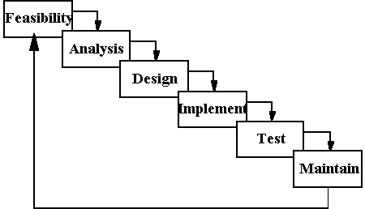

8.1 FEASIBILTY STUDY
From the inception of ideas for software system, until it is implemented and delivered to customer and even after that the system undergoes gradual developments and evaluations. The software is said to have life cycle composed of several phases.
At the feasibility stage, it is desirable that two or three different configuration will be pursed that satisfy the key technical requirement but which represent different level of ambition and cost.
Feasibility is the determination of whether or not a project is worth doing. A feasibility study is carried out select a best system that mate performance requirements.
The data collected during primary investigation examines system feasibilities that is likelihood that the system will be beneficial to the organization. Feasibility study is done so that an ill-conceived system is recognized early in definition phase. During system engineering, however, we concentrate our attention on four primary areas of interest. This phase is really important as before starting with the real work of building the system it was very important to find out whether the idea thought is possible or not.
Types of Feasibility--
- Economic Feasibility: An evaluation of development cost weighted against the ultimate income or benefit derived from the developed system.
- Technical Feasibility: A study of function, performance and constraints that may affect the ability to achieve an acceptable system.
- Operational Feasibility: A study about the operational aspects of the system.

Economic Analysis :
Among the most important information contained in feasibility study is Cost Benefit Analysis and assessment of the economic justification for a computer based system project. Cost Benefit Analysis delineates costs for the project development and weighs them against tangible and intangible benefits of a system. Although this system eliminates paper work considerably yet we should consider various costs associated with this. Cost Benefits Analysis is complicated by the criteria that vary with the characteristics of the system to be developed, the relative size of the project and the expected return on investment desired as part of company’s strategic plan. In addition, many benefits derived from a computer-based system are intangible (e.g. better design quality through iterative optimization, increased customer satisfaction through programmable control etc.)

Cost Benefit Analysis :
The various costs evaluated include:
- Equipment Costs.
This includes capital and leasing costs of
- Computer and peripherals.
- The initial systems supplies. (E.g. disks, tapes, etc.)
- Additional hardware.
- UPS and Voltage Regulators.
- Development Costs.
- The purchasing of software. (Programming, DB and OS’s)
- Consulting work.
- System analysis and programming.
- Installation Costs.
- Preparation of the computer room.
(E.g. wiring, air-conditioning, etc.)
- Accommodation (e.g. new building or building alteration,
Etc.)
- Personal Costs.
- Staff training. (Assumption: we will be incurring the cost to train the employees in the Proposed Leave System)
- Staff recruitment or relocations.
- Staff salaries.
- Redundancy payments.
- Operating Costs.
- Consumable (e.g.- tapes, disks, stationery)
- Accommodation costs.
- Power.
- Insurance.

Technical Analysis :
During technical analysis, the technical merits of the system are studied and at the same time collecting additional information about performance, reliability, maintainability and predictability.
Technical analysis begins with an assessment of the technical viability of the proposed system.
- What technologies are required to accomplished system function and performance?
- What new materials, methods, algorithms or processes are required and what is their development risk?
- How will these obtained from technical analysis form the basis for another go/no-go decision on the test system? If the technical risk is severe, if models indicate that the desired function can not be achieved, if the pieces just won’t fit together smoothly-it’s back to the drawing board.
As the software is vary much economically feasible, then it is really important for it to be technically sound. The software will be build among:
- Front-End: ASP.NET 3.5
- Back-End: MS SQL SERVER 2000
Operational Feasibility :
The project is operationally feasible. This project is being made for the convenience of the managers and employees only. This system will greatly reduce a huge burden of managers and employees. So because of the above stated advantages the users of the system will not be reluctant at all.

8.2 Software Requirement Specification

The software requirement specification is produced at the culmination of the analysis task.

Purpose
The purpose of this Software Requirement Specification (SRS) is to
fully describe the behavior of the “ SYSTEM” being developed. It also describes the nonfunctional requirements, design constraints and other factors necessary to provide a complete and comprehensive description of the requirements.

User Characteristics
Administrator : Deep knowledge of computers as well as company policies.
Employees : Basic knowledge of handling computers is required.
This software has been designed keeping in view the requirements and ease of the user who is finally going to use it. After all the effort put on analysis phase, I ended up with the following requirements:
- Easy storage, updation, deletion and retrieval of data.
- No redundancy of data.
- Minimal traversal time.
- User friendly interface.
- Proper validations and checks for the data to be entered.
- Generation of certain automatic values.
- Compatibility with other Microsoft based softwares.

General Constraints
The Online Trading System shall execute online. The said application is a server-side application and the product code shall be written in ASP.NET using C#.NET and VB.NET. The database will be managed in SQL Server. A standard QWERTY keyboard is associated with each workstation.
The application is allocated the responsibility for ensuring that only authorized data-entry operators, employees can access the records and availability to anyone who has a computer and an internet connection.

Assumptions
This application is released with an implicit assumption that it is made to work online for applying of Equities and viewing customers records with the broker.

Functional Requirements
The function and performance specification for the system is divided into two major roles: Admin and customer. These functions can be accessed after going through the Login Screen which is a welcome page.

Introduction: It deals with the administrator’s login that has complete access to all files and records there in.

Inputs: The main data that is inputted is the Customer Code of the administrator to keep track of authorization and authentication.

Processing: The input is processed with the help of a cookie or a query string. An admin can create new records, edit old ones and delete the unnecessary.

Outputs: Maximum output is generated through this section. The Admin is responsible for adding all the basic information and codes which are used further while entering employee related information and equipment related information too.

8.3 SYSTEM ANALYSIS
The Analysis model:
The analysis model must achieve three primary objectives:
- To describe what the customer requires.
- To establish the basis for the enhancement of a software design.
- To define a set of requirements that can be validated once the software is completely enhanced. The main elements of the analysis model are briefly described below.
Data
Dictionary
Entity Relationship
Diagram
Data Object Description
Process Specification
Data Flow Diagram
State Transition Diagram
Control Specification

- At the core of the model lies the data dictionary, which is a repository that contains descriptions of all the data objects consumed or produced by the software .Three different diagrams surround the core.
- The entity relation diagram depicts relationships between data objects.
- The data flow diagram provides an indication of how the data is transformed as they move through the system.
- The state transition diagram indicates how the system behaves as a consequence of external events.

8.4 REQUIREMENT ANALYSIS
Goal of Thesis
The goal of our thesis is to develop a website that can be used as an enrollment website with the features of interaction and problem solving. The whole project will be based on PHP with MYSQL as the database with certain security constraints added to it.
Our aim is also to implement the Administrator part in to the project so that the server or administrator himself can view, add, delete and modify.
- Administrator
He has to see whether the website is working properly and whether the details available in the system are relevant and correct. He can view, add, modify, delete details.
- Database
The database keeps all the records of all the users i.e. name,course, phone no.,dob, city, country,etc. For creating such records it takes the help of tables which is created in the MYSQL. The tables can have infinite entries of all the registered users as well as administrators.
- Clients
Our aim will also to provide efficient way by which client can enter to see his profile, ask questions to his teacher and download softwares.
- Security Constraints
There need to be certain constraints which have to be implemented on the database as well as on the administrator in order to work properly the whole system, such as declaring the primary key, or such constraints in order to keep the database work properly.
Some of such constraints are as follows :
1. Each user has a field called username which can be used to differentiate between different users.
2. The administrator has his own password known to no one else to access a unique page.
3. Only the administrator has the right to delete, modify users and questions.
4. Administrator has to first login to get access to myaccount part and modify some data available in the website.
5. A new user cannot have same username and password as of some already registered user.
6.When user or administrator click on logout the session of the user ends and he has to again login using his/her username and password to access the same functionality.
7. Checks are implemented so that the mandatory fields are filled by users when the user is entering some information in the system.
8. Latest firewalls and other antivirus and anti hacking modules are to be used with the website so as to protect the website from external attacks.

8.5 PROBLEM ANALYSIS :
APPLICATIONS
The main applications of the On Line Placement System is the ability of the website to properly show enroll the artists and manage information about them. The administrator has the ability to change ,modify, view and delete the various details regarding the users and arts. The users have the ability to log in and post their queries and download arts.
CHALLENGES
The challenges mainly lie in detecting attacks like viruses, hacking and also in the implementation of firewall. A virus can enter the system and can disrupt the working of the website. Hacking can be done by some people who want to access some restricted sections of the website (e.g. administrator’s area) and to modify or taper some aspects of the website.
Scanning attacks may yield:
(i) The method used by viruses to enter the system.
(ii) The types of database allowed through a firewall.
(iii) The paths or ways used by hackers to enter the system
(iv) The loopholes remaining in the system (or website) which are used by attackers.
(v) The server from where the viruses or hackers are gaining access to the system.
(vi) The types of viruses able to affect the website.
And with the implementation of firewall and other security mechanisms that are designed for it, the On Line Placement System Website safe and secure.

FEASIBILTY STUDY
From the inception of ideas for software system, until it is implemented and delivered to customer and even after that the system undergoes gradual developments and evaluations.
The software is said to have life cycle composed of several phases.
At the feasibility stage, it is desirable that two or three different configuration will be pursed that satisfy the key technical requirement but which represent different level of ambition and cost.
Feasibility is the determination of whether or not a project is worth doing. A feasibility study is carried out select a best system that mate performance requirements.
The data collected during primary investigation examines system feasibilities that is likelihood that the system will be beneficial to the organization. Four tests for feasibility study are as follows:-
Technical Feasibility: This is concerned with specifying equipment and software that will successfully satisfy the use considerably, but might includeThe feasibility to produce output in a given time because system is fast enough to handle multiple users. Response time under certain circumstances and ability to process a certain volume of transaction of a particular speed.
Economical Feasibility: Economic analysis is the most frequently used technique used for evaluating the effectiveness of a proposed system. More commonly known as cost/benefit analysis the procedure is to determine the benefits and savings that are expected from a proposed system and compared them with cost. Though the cost of installing the system may appear high, it is one time investment. The resulting benefits is that automation results in turnaround time. The resulting cost/benefit ratio is favorable.
Operational Feasibility: It is mainly related to human organizational as social aspects. The points to be considered are - The system interface is standard, user friendly and provides extensive help. Hence no special training is not required.
Social Feasibility: Social feasibility is determination of whether a proposed project will be acceptable to people or not, So this project is totally Social and Feasible

SYSTEM ANALYSIS :
The Analysis model:
The analysis model must achieve three primary objectives:
- To describe what the customer requires.
- To establish the basis for the enhancement of a software design.
- To define a set of requirements that can be validated once the software is completely enhanced. The main elements of the analysis model are briefly described below.
- At the core of the model lies the data dictionary, which is a repository that contains descriptions of all the data objects consumed or produced by the software .Three different diagrams surround the core.
- The entity relation diagram depicts relationships between data objects.
- The data flow diagram provides an indication of how the data is transformed as they move through the system.
8.6 SYSTEM DESIGN PHASE
The design phase involves converting the informational, functional, and network requirements identified during the initiation and planning phases into unified design specifications that developers use to script programs during the development phase. Program designs are constructed in various ways. Using a top-down approach, designers first identify and link major program components and interfaces, then expand design layouts as they identify and link smaller subsystems and connections. Using a bottom-up approach, designers first identify and link minor program components and interfaces, then expand design layouts as they identify and link larger systems
Contemporary design techniques often use prototyping tools that build mock-up designs of items such as application screens, database layouts, and system architectures. End users, designers, developers, database managers, and network administrators should review and refine the prototyped designs in an iterative process until they agree on an acceptable design.
Designers should carefully document completed designs. Detailed documentation enhances a programmer’s ability to develop programs and modify them after they are placed in production. The documentation also helps management ensure final programs are consistent with original goals and specifications. Organizations should create initial testing, conversion, implementation, and training plans during the design phase. Additionally, they should draft user, operator, and maintenance manuals.
For design of the website project:
- First Database has to be designed which can be used to handle all the requirements of the users.
- The basic structure of the website has to be designed.
- The main template to be used for the website is designed.
8.6.1 Introduction
System design is the process of developing specifications for a candidate system that meet the criteria established in the system analysis. Major step in system design is the preparation of the input forms and the output reports in a form applicable to the user.
The main objective of the system design is to make the system user friendly. System design involves various stages as:

Data Entry
- Data Correction
- Data Deletion
- Processing
- Sorting and Indexing
System design is the creative act of invention, developing new inputs, a database, offline files, procedures and output for processing business to meet an organization objective. System design builds information gathered during the system analysis.

8.6.2 CHARACTERSTICS OF A WELL DEFINED SYSTEM
In design an efficient and effective system is of great importance to consider the human factor and equipment that these will require to use. System analyst must evaluate the capabilities and limitations of the personal and corresponding factors of the equipment itself.
The characteristics associated with effective system operations are:
- Accessibility

Decision Making Ability
- Economy
- Flexibility
- Reliability

Personnel: If the operating system is convinced that the new system will not benefit them, it appears one, and the system is in serious trouble. To overcome this resistance participation by operating personal during all phases of the changeover is necessary because they constitute the organization, which must use alive in with newly design system. An effective system produces not only information at the lowest cost pertinent and timely for making decision.
The main objective of the system design is to make the system user friendly. After discussing with some of the technical persons, friends, guide; it was concluded that the design of the application should be 3 tier which means that the system will be developed in orientation to three things:
Data: It includes Database, Stored Procedures, and Cursors etc.
Business: It includes the logic that will actually process the data but it should be in the form of objects and classes that will help in providing the application components reusability, abstraction and other Object Oriented features.
Presentation: It includes the front end that links the user to the whole system.
Generally, it is said that if the design is made well, the whole system will work well. So, I have tried my best to put my effort on this phase properly.

Benefits of the System
The system provides the following benefits:
Menu Driven Package:
The system consists of various menus through which we can choose various options.
These menus are self explanatory and allow the user to browse through the various forms.
Easy Retrieval of Data:
Operations like add, update, delete, save and cancel etc. have been accomplished with the
help of various buttons and list boxes. The user can easily view or retrieve information.
Validations:
There are proper validations for the information to be filled at the relevant places. So, the
chances of wrong entry are minimal.
Security and Access:
The system is fully secured by a password facility so that nobody can use the system or
view information without the right and the permission. Only the correct password allows
further navigation in the project.
User friendly:
The system is completely user friendly so that the end user who may have very little
knowledge of using computers can easily use the system.

9. Data Flow Diagram
In our DFD, we give names to data flows, processes, and data stores. Although the names are descriptive of the data, they do not give details. So the following the DFD, our interest is to build some structured place to keep details of the contents of data flow, processes, and data store. A data dictionary is a structured repository of data about data. It is a set of rigorous definition of all DFD data element and data structure

9.1 DFD Symbols
In the DFD, there are four symbols,
- A Square defines a source (originator) or destination of system data.
- An Arrow identifies data flow- data in motion .It is pipeline through which information flows.
- A circle or a bubble (or a oval bubble) represents a process that transforms incoming data flow(s) into outgoing data flow(s)
- An open rectangle is a data store-data at rest , or temporary repository of data

9.2 DFD Rules and Tips
- Each process should have at least one input and an output.
- Each data store should have at least one data flow in and one data flow out.
- Data stored in a system must go through a process
- All processes in a DFD go to another process or a data store.
.

9.3 DATA FLOW DIAGRAM :

Authenticated users are connected to the System
Client 3
Client 2
Client 1

Check Validation
DownLoad Various images

Main System Representing Art Gallery
Upload Arts
Database server for valid user
Register for
DownLoad Arts

View
Save to folder
DownLoad at client side
Arts
Database
Search
Arts
Client
Database
About Us
Home
Contact
us

DFD level 0:
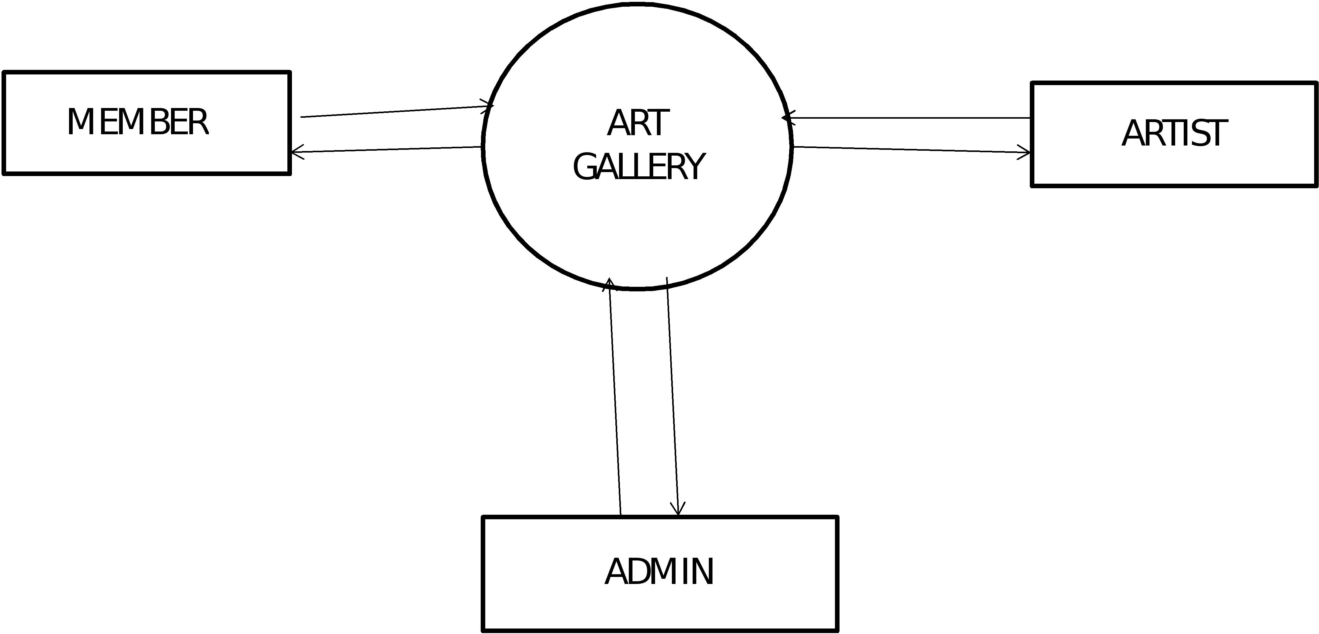

DFD level 1 member:
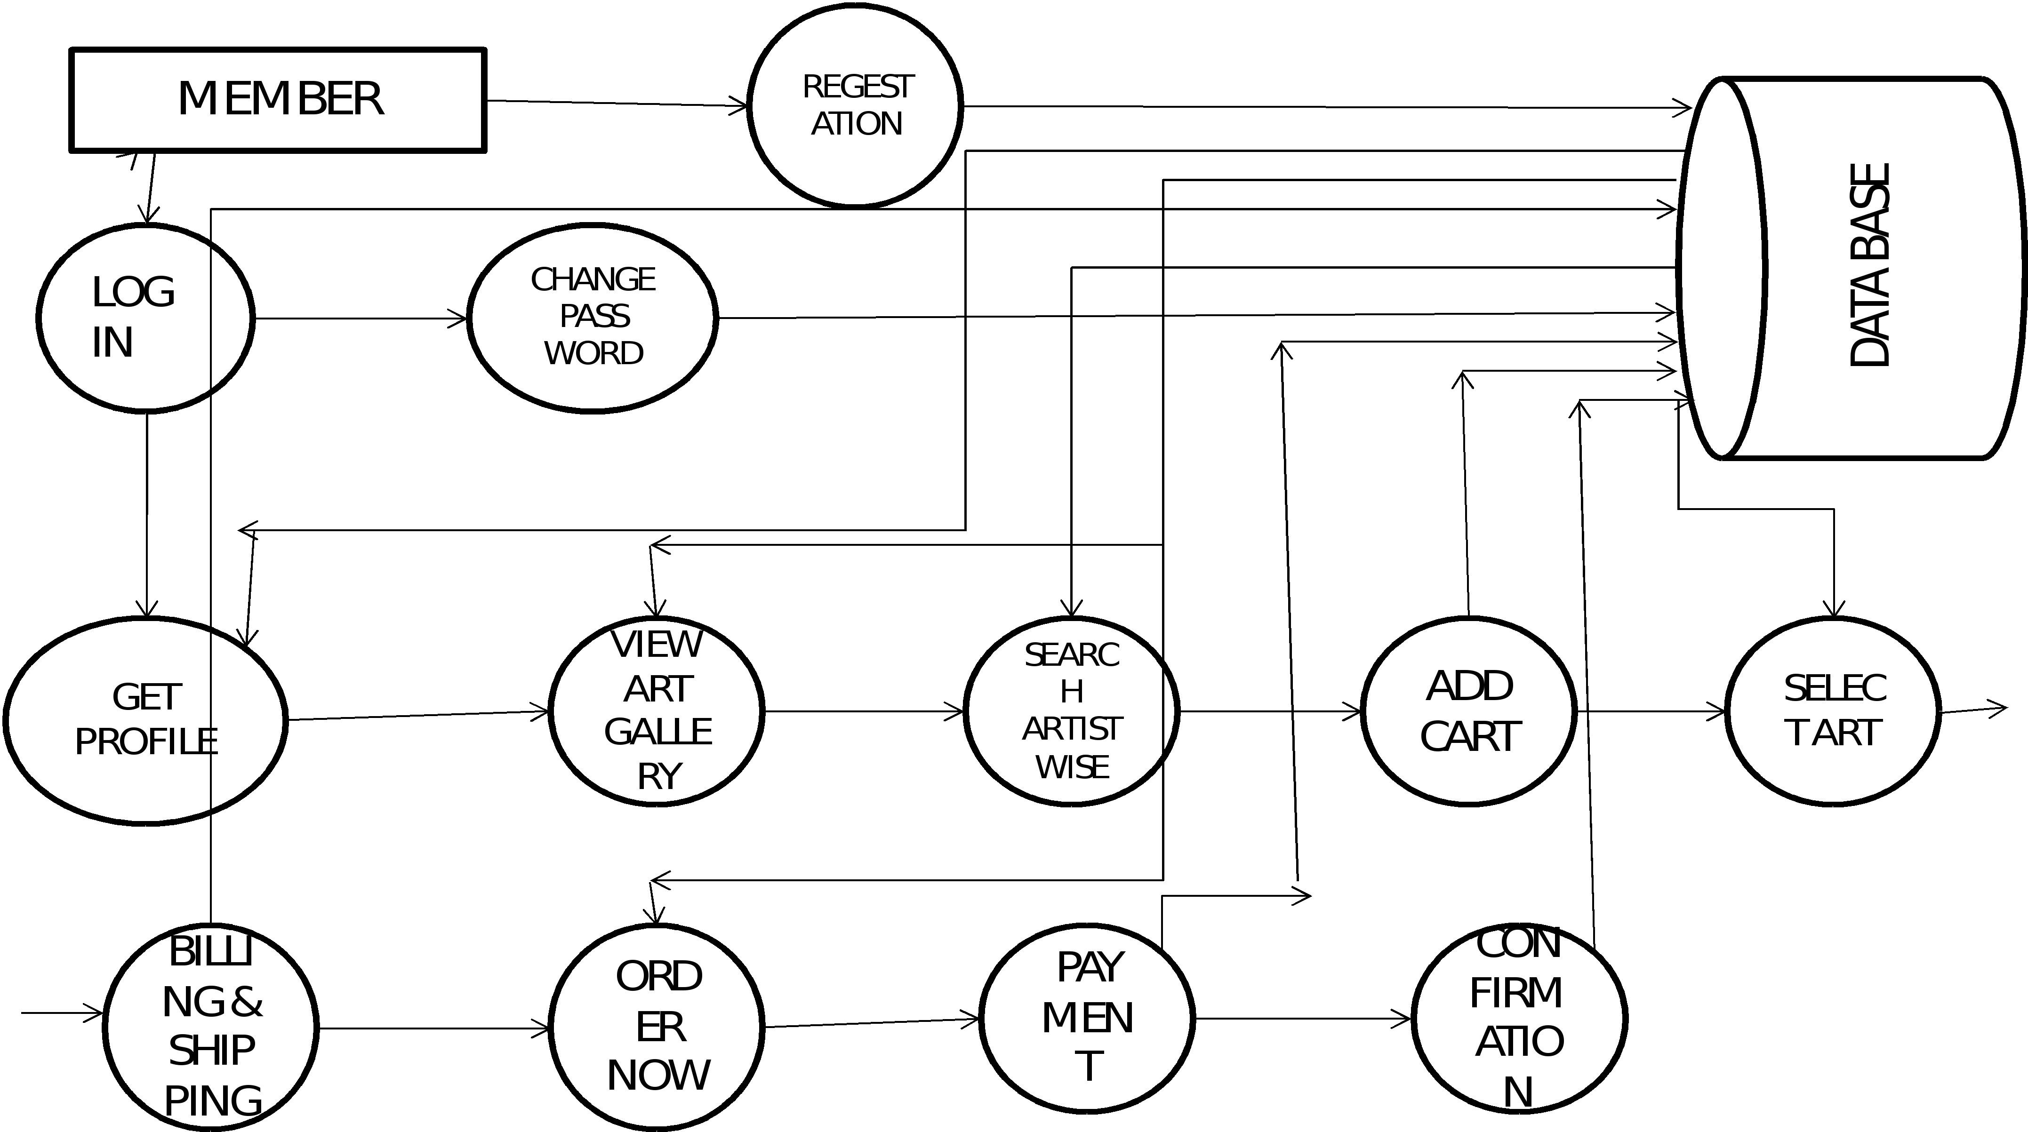
DFD Level 1 Artist:
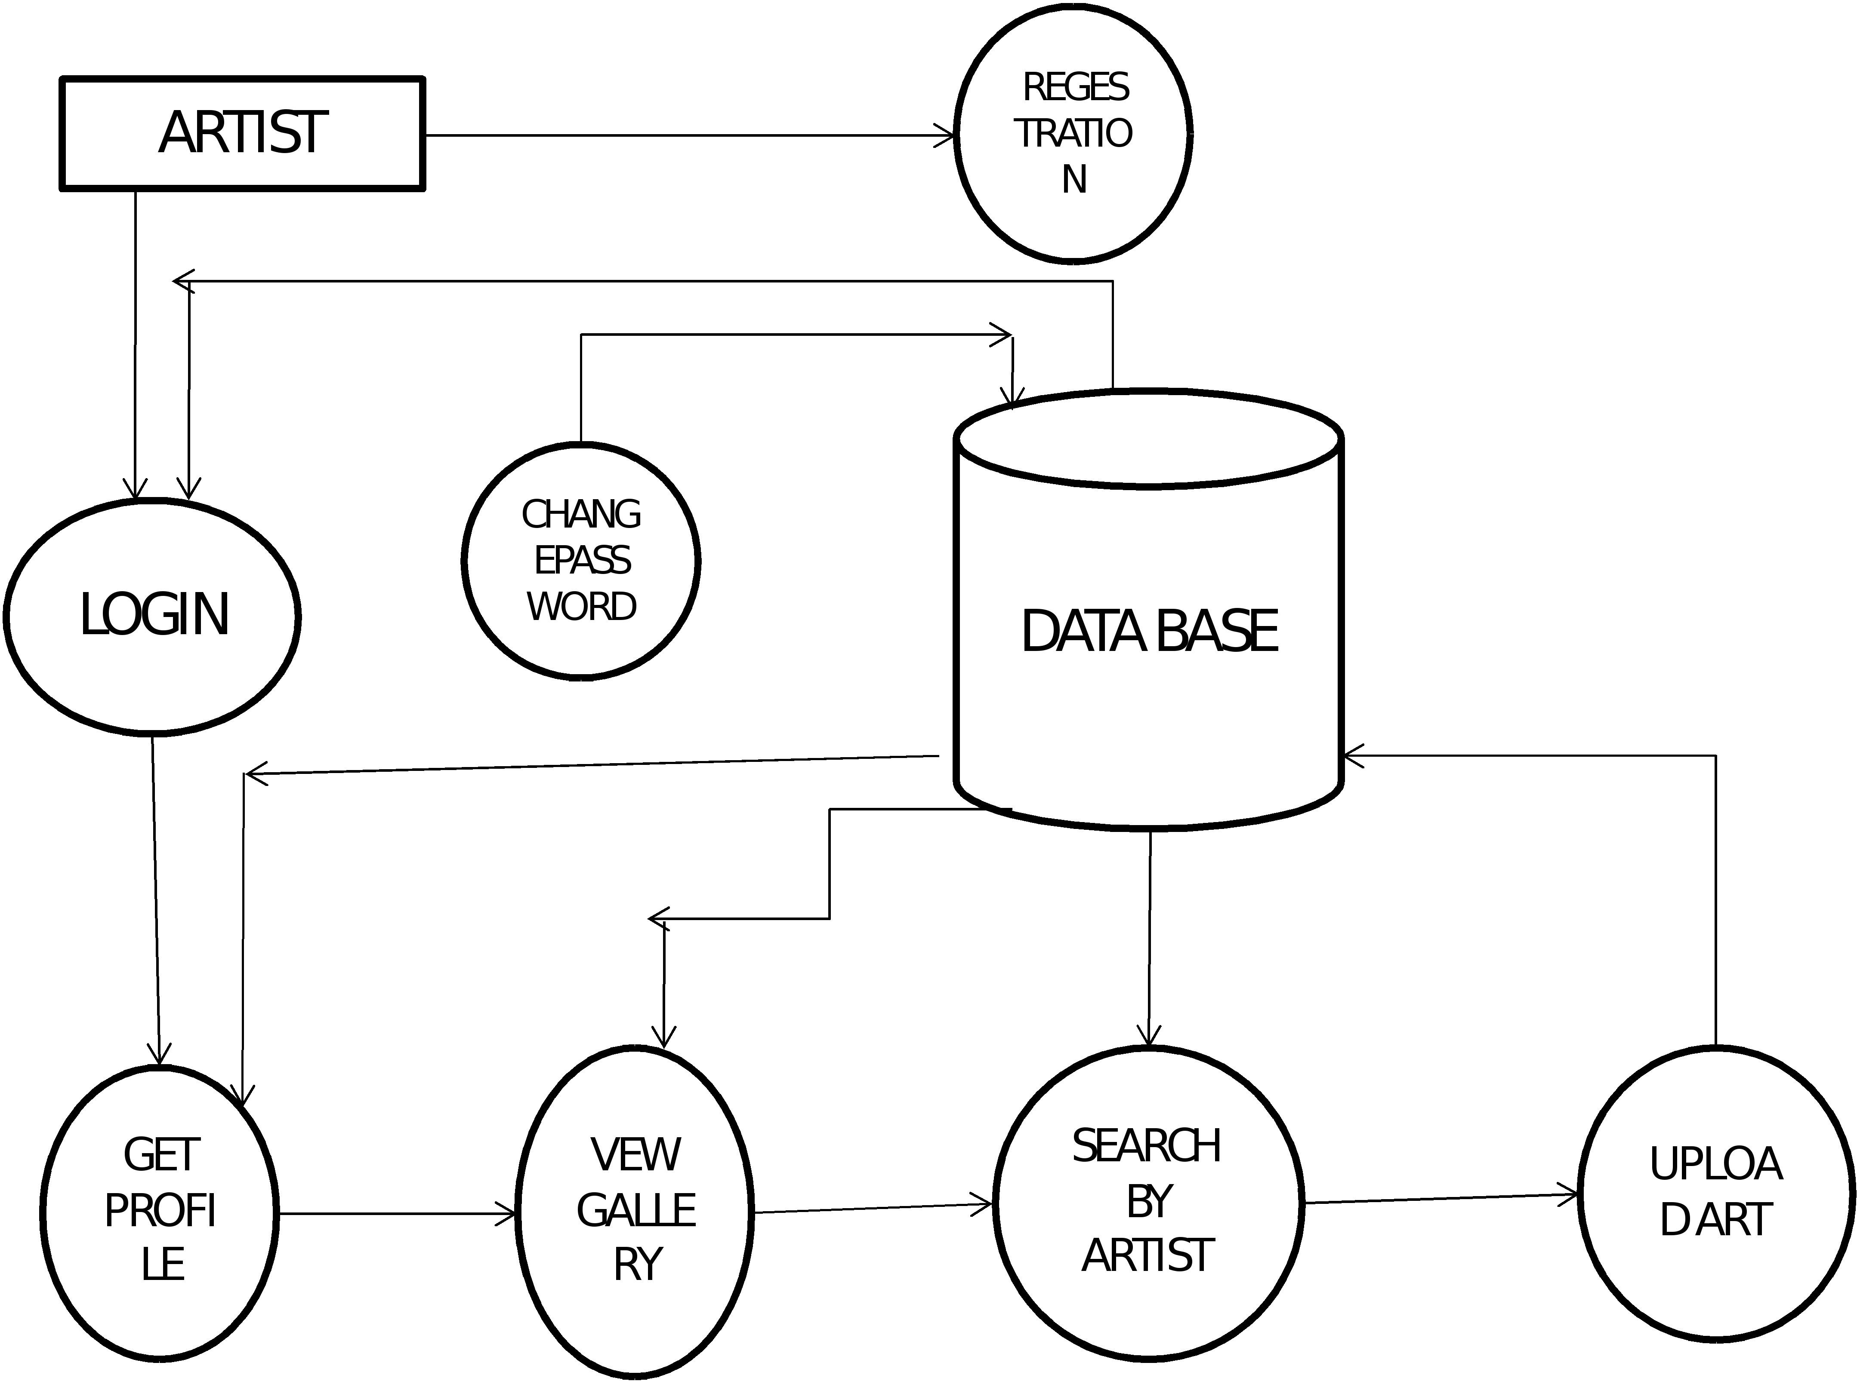

DFD Level 1 Admin:

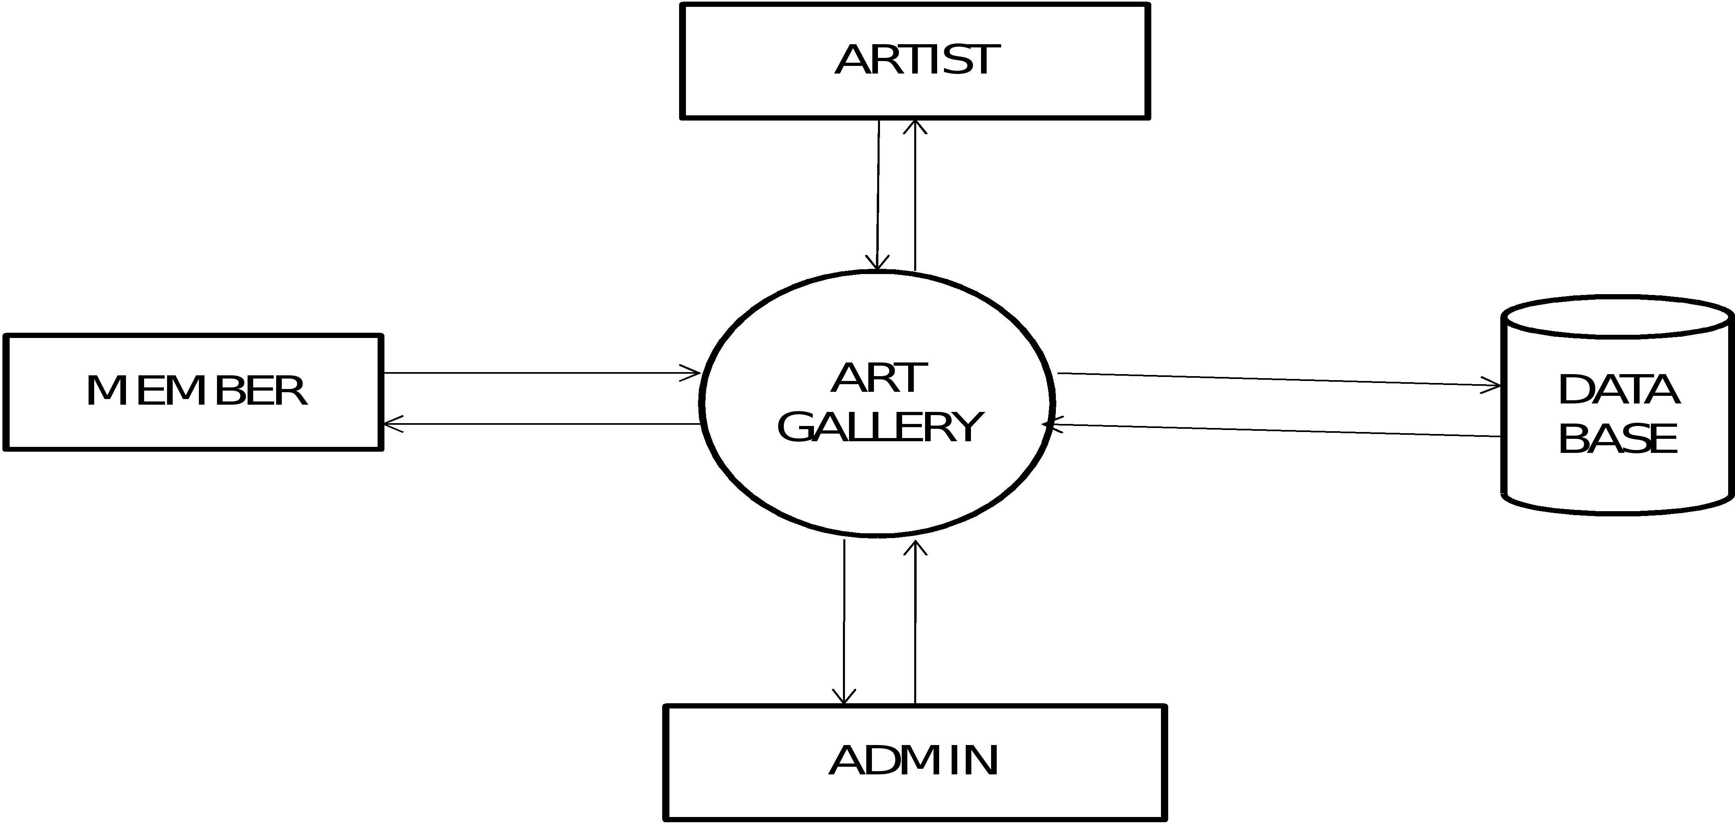
Context Diagram:
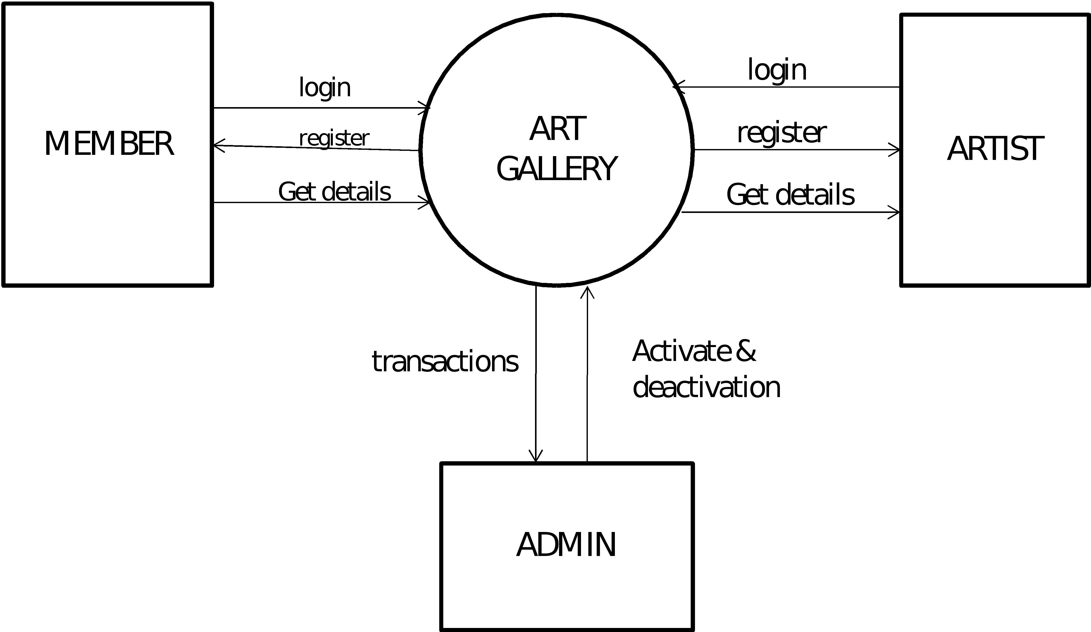

9.4 FUTURE ENHANCEMENTS
We can have a Website that will cover whole India giving details of Arts created by persons.
The On Line Art Gallery website will have the prominent features including:
  - Providing online Arts through our site.
  - Providing personalized inbox to the user.
  - Providing video conferencing with the Artists
  - Providing links to news which will elaborate more information about them.
  - Providing Ajax technology refreshing In our website.

10. TESTING
10.1 Software testing
Software testing is the process used to measure the quality of developed computer software. Usually, quality is constrained to such topics as correctness, completeness, security, but can also include more technical requirements as described under the ISO standard ISO 9126, such as capability, reliability, efficiency, portability, maintainability, compatibility, and usability. Testing is a process of technical investigation, performed on behalf of stakeholders, that is intended to reveal quality-related information about the product with respect to the context in which it is intended to operate .

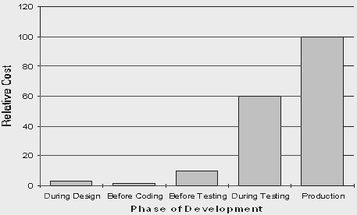

White box, black box, and grey box testing
Black box testing treats the software as a black-box without any understanding as to how the internals behave. Thus, the tester inputs data and only sees the output from the test object. This level of testing usually requires thorough test cases to be provided to the tester who then can simply verify that for a given input, the output value (or behavior), is the same as the expected value specified in the test case.
White box testing, however, is when the tester has access to the internal data structures, code, and algorithms. For this reason, unit testing and debugging can be classified as white-box testing and it usually requires writing code, or at a minimum, stepping through it, and thus requires more skill than the black-box tester. If the software in test is an interface or API of any sort, white-box testing is almost always required.
In recent years the term grey box testing has come into common usage. This involves having access to internal data structures and algorithms for purposes of designing the test cases, but testing at the user, or black-box level. Manipulating input data and formatting output do not qualify as grey-box because the input and output are clearly outside of the black-box we are calling the software under test. This is particularly important when conducting integration testing between two modules of code written by two different developers, where only the interfaces are exposed for test.
Grey box testing could be used in the context of testing a client-server environment when the tester has control over the input, inspects the value in a SQL database, and the output value, and then compares all three (the input, sql value, and output), to determine if the data got corrupt on the database insertion or retrieval.
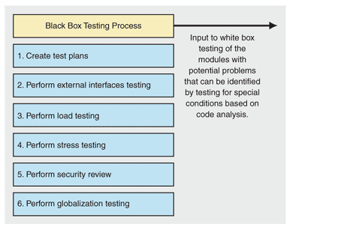

10.2 Verification and Validation

Software testing is used in association with verification and validation (V&V). Verification is the checking of or testing of items, including software, for conformance and consistency with an associated specification. Software testing is just one kind of verification, which also uses techniques such as reviews, inspections, and walkthroughs. Validation is the process of checking what has been specified is what the user actually wanted.
- Verification: Have we built the software right? (i.e. does it match the specification).
- Validation: Have we built the right software? (i.e. Is this what the customer wants?)
Level of testing
- Unit testing tests the minimal software component, or module. Each unit (basic component) of the software is tested to verify that the detailed design for the unit has been correctly implemented. In an Object-oriented environment, this is usually at the class level, and the minimal unit tests include the constructors and destructors.
- Integration testing exposes defects in the interfaces and interaction between integrated components (modules). Progressively larger groups of tested software components corresponding to elements of the architectural design are integrated and tested until the software works as a system.
- Functional testing tests at any level (class, module, interface, or system) for proper functionality as defined in the specification.
- System testing tests a completely integrated system to verify that it meets its requirements.
- System integration testing verifies that a system is integrated to any external or third party systems defined in the system requirements.
- Acceptance testing can be conducted by the end-user, customer, or client to validate whether or not to accept the product. Acceptance testing may be performed as part of the hand-off process between any two phases of development.
  - Alpha testing is simulated or actual operational testing by potential users/customers or an independent test team at the developers' site. Alpha testing is often employed for off-the-shelf software as a form of internal acceptance testing, before the software goes to beta testing.
  - Beta testing comes after alpha testing. Versions of the software, known as beta versions, are released to a limited audience outside of the company. The software is released to groups of people so that further testing can ensure the product has few faults or bugs. Sometimes, beta versions are made available to the open public to increase the feedback field to a maximal number of future users.
It should be noted that although both Alpha and Beta are referred to as testing it is in fact use immersion. The rigors that are applied are often unsystematic and many of the basic tenets of testing process are not used. The Alpha and Beta period provides insight into environmental and utilization conditions that can impact the software.
After modifying software, either for a change in functionality or to fix defects, a regression test re-runs previously passing tests on the modified software to ensure that the modifications haven't unintentionally caused a regression of previous functionality. Regression testing can be performed at any or all of the above test levels. These regression tests are often automated.

SMOKE TESTING

Smoke testing is a term used in plumbing, woodwind repair, electronics, and computer software development. It refers to the first test made after repairs or first assembly to provide some assurance that the system under test will not catastrophically fail. After a smoke test proves that the pipes will not leak, the keys seal properly, the circuit will not burn, or the software will not crash outright, the assembly is ready for more stressful testing.

- In plumbing, a smoke test forces actual smoke through newly plumbed pipes to find leaks, before water is allowed to flow through the pipes.
- In woodwind instrument repair, a smoke test involves plugging one end of an instrument and blowing smoke into the other to test for leaks. (This test is no longer in common use)
- In electronics, a smoke testing is the first time a circuit is attached to power, which will sometimes produce actual smoke if a design or wiring mistake has been made.
- In computer programming and software testing, smoke testing is a preliminary to further testing, which should reveal simple failures severe enough to reject a prospective software release. In this case, the smoke is metaphorical

11. IMPLEMENTATION PHASE
The implementation phase involves installing approved applications into production environments. Primary tasks include announcing the implementation schedule, training end users, and installing the product. Additionally, organizations should input and verify data, configure and test system and security parameters, and conduct post-implementation reviews. Management should circulate implementation schedules to all affected parties and should notify users of any implementation responsibilities.
After organizations install a product, pre-existing data is manually input or electronically transferred to a new system. Verifying the accuracy of the input data and security configurations is a critical part of the implementation process. Organizations often run a new system in parallel with an old system until they verify the accuracy and reliability of the new system. Employees should document any programming, procedural, or configuration changes made during the verification process.
For implementation of the website project:
- The website can be installed on a computer or a server which has PHP and MYSQL installed in it.
- The owners of the website are to be properly trained to use all the features of the website, giving details of each features of the website.
12. TEST PLAN
The testing phase requires organizations to complete various tests to ensure the accuracy of programmed code, the inclusion of expected functionality, and the interoperability of applications and other network components. Thorough testing is critical to ensuring systems meet organizational and end-user requirements. Test plans created during initial project phases enhance an organization’s ability to create detailed tests.
A bottom-up approach tests smaller components first and progressively adds and tests additional components and systems. A top-down approach first tests major components and connections and progressively tests smaller components and connections.
Bottom-up tests often begin with functional (requirements based) testing. Functional tests should ensure that expected functional, security, and internal control features are present and operating properly. Testers then complete integration and end-to-end testing to ensure application and system components interact properly. Users then conduct acceptance tests to ensure systems meet defined acceptance criteria. Organizations should review and complete user, operator, and maintenance manuals during the testing phase. Additionally, they should finalize conversion, implementation, and training plans.

12.1 Testing the system:
Testing can be done with two types of data. These are as following:-
Live Data
Live data is actually to be used in the proposed system.
Test Data:
Test data is previously designed sample input to achieve predictable results.
Test Objective:

Testing is a process of execution a program with the intent of finding error.
- A good test case is one that has a high probability of finding an undiscovered error.

Testing Levels
Software testing is usually done at several levels. They are commonly referred to as unit testing, integration testing, and system testing.

Test Phases
There is several type of testing in a comprehensive software test process, many of which occur simultaneously.

Unit Test
The objective of unit testing is to verify that individual units -- the smallest compliable components, such as functions & modules-- function correctly. This is done to ensure that no bugs are present in the very basic structure of the program.
Unit testing is also called component testing. However, component testing is sometimes considered to be a level of testing above unit testing. This may be the case with a system that contains individually testable components that are composed of multiple units. For example in the visual basic interface, in a system that contains forms and modules, the functions could be tested as units and the whole form could be tested as component.
Unit testing tests software in terms of a unit: a module, a function, a specific section of code. This testing occurs while the software is being developed and before all the pieces of code complete.
My Project Network Management software each function and event has been tested individually.

Integration Testing
The objective of integration testing is to test the integration of and communication between components. Additionally, it may include testing the integration of subsystems or communication with external systems
On some projects, integration testing may be divided into two levels: Assembly Testing and System Integration Testing.
During Assembly testing, the integration of the software components is tested.
During system Integration testing, the communication with external systems is tested.
In Integration testing, individual modules are put together making a larger application. This can be done repeatedly until the program is assembled in its entirety.
The individual components are combined with other components to make sure that necessary communications, links and data sharing occur properly. It is not truly system testing because the components are not implemented in the operating environment. The integration phase requires more planning and some reasonable sub-set of production-type data. Larger systems often require several integration steps.
There are three basic integration test methods:
- All-at-once
- Bottom-up
- Top-down
The all-at-once method provides a useful solution for simple integration problems, involving a small program possibly using a few previously tested modules.
Bottom-up testing involves individual testing of each module using a driver routine that calls the module and provides it with needed resources. Bottom-up testing is a more intuitive approach to testing that also usually finds errors in critical routines earlier than the top-down method. However, in a new system many modules must be integrated to produce system-level behavior, thus interface errors surface late in the process.
Top-down testing fits a prototyping environment that establishes an initial skeleton that fills individual modules are completed. The method lends itself to more structured organizations that plan out the entire test process. Although interface errors are found earlier, errors in critical low-level modules can be found later than you would like.
What all this implies is that a combination of low-level bottom-up testing works best for critical modules, while high-level top-down modules provide an early working program that can give management and users more confidence in results early on in the process. There may be need for more than one set of integration environments to support this hybrid approach.

System Testing
The objectives of system testing are to find defects that are attributable to the behavior of the system as a whole, rather than the behavior of individual components, and to test that the software functions as a complete system. This level of testing is different from integration testing in that the tests are concerned with the entire system, not just the interactions between components. Other than system functionality and behavior, system testing may include testing configuration, throughput, security, resource utilization, and performance.

Test Design
Just as the components of a system must be designed, tests for a system must be designed. Two common methods of test design are black box testing and white box testing. After the tests are implemented, though, the test design method may not be evident.

Black Box
In black box testing the tester knows nothing at all about the inside of the system he or she is testing. The system is tested by throwing inputs at it like throwing pennies down a well and waiting for a splash.
Black box testing focuses on designing tests that view components as opaque. The implementation details of the components are not known (or, at least, are ignored), and only externally observable behavior or functionality is tested. Other terms for black box testing are functional testing and behavioral testing.
However, behavioral testing and black box testing are slightly different. Even though both view components as black boxes, behavioral testing allows knowledge of the implementation details of components to be used in test design if necessary.
You can re-run black box tests after a change to make sure the change only produced intended results with no inadvertent effects.

White Box
In white box testing (also called glass box), the tester has knowledge of the internals of the system. Software developers on a project are best able to do this kind of testing, since they know which areas may be weak.
White box testing focuses on designing tests that view components as transparent. The implementation details of the components are known, and that knowledge is used in test design and creation of test data. Other terms for white box testing are structural testing and clear box testing.

Quality Assurance Test
Some organizations maintain a Quality Group that provides a different point of view, uses a different set of tests, and applies the tests in a different, more complete test environment. The group might look to see that organization standards have been followed in the specification, coding and documentation of the software. They might check to see that the original requirement is documented, verify that the software properly implements the required functions, and see that everything is ready for the users to take a crack at it.

User Acceptance Test and Installation Test
Traditionally, this is where the users ‘get their first crack’ at the software. Unfortunately, by this time, it's usually too late. If the users have not seen prototypes, been involved with the design, and understood the evolution of the system, they are inevitably going to be unhappy with the result. If you can perform every test as user acceptance tests, you have a much better chance of a successful project.

Repair
The whole point of all quality processing is to prevent defects as much as possible, and to discover those defects that do occur before the customer does. The repaired code should start the testing process all over again.
Risk analysis

New circle addition

System crash

Network flaws (busy or crashed)

Careless data entry

Platform specific (windows compatible)
For testing of the website:
- All the features of the website are tested by running each function available in the website.
- The results of the tests conducted on the website are analyzed properly.
- Only after getting satisfactory results of testing the website can be uploaded on the network i.e. internet.

VALIDATION CHECKS:
A common problem with computer system is that it is very easy to put incorrect data into them. So the input data is validated to minimize errors and data entry. For certain data specific code has been given and validations are done which enable the user to enter the required data and correct them if they have entered wrong codes, e.g. you could mistype a link name or a URL in a database resulting in reports being occurred in the wrong link name. If you put incorrect data into the computer system then you will get incorrect results out of it. Processing incorrect inputs will produce incorrect outputs. This lead to the acronym: GIGO (Garbage in Garbage Out).
Sometimes incorrect data can actually cause a computer system to stop work temporarily. This is a particular problem in batch processing systems when data may be processed overnights. If incorrect data stops a batch processing systems for working then a whole night processing time may be lost.
People who develop computer systems got to a lot of trouble to make it difficult for incorrect data to be entered. The two main techniques used for this purpose are:
- VERIFICATION
- VALIDATION
These techniques are described in details below.
- VERIFICATION:
A verification check ensures that data is correctly transferred into a computer from the medium that it was originally stored on. Verification checks are usually used to check that a data entry worker has correctly typed information written on a data collection form into a computer.
- VALIDATION:
A validation check is an automatic check made by computer to ensure that any data entered into the computer is sensible. A validation check does not make sure that data has been entered correctly. It only ensures that data is sensible. For this reason validation checks are not usually as effective as verification checks. They can however be carried out automatically by the computer and therefore require less work by the computer operators making them cheaper to use.

Validators used in the project --
Six types of validators are used in the project-
1.Required Field Validator – It is used to check nul values
2.Compare Validator –It is used to compare Controls.
3.Range Validator – It is used to specify range.
4.Regular Expression Validator-In tis we have some pre defined formats like valid email address,valid internet address etc
5. Custom Validator.--If our requirement is not satisfied in abobe all, then we can use this one.
6. Validation Summary—To display the summary of above validators.

Checks applied on forms in project—
1.Field can’t be null
2.Valid Email Address
3.Phone number,fax, etc should be integer.
4.Names sould be in string format.
5.Date should be in correct format.
6. Address should be in Varchar,

System Implementation
This phase is less creative than design phase. It is primarily concerned with user training, site preparation and file conversions. The final communications and links to other modules and hardware components are established to make the software operative. After that the program is run with live data otherwise a diagnostic.
- SOLUTION REQUIREMENTS
Implementation implies what configurations are required to implement the given software at the end user’s site, which are as follows:

- There must be a LAN available on which the system can work.
- There must be .Net Framework 3.5 loaded on all the computers that will provide support to the computer on which the application is running. Then, install the installation on the system using its installer.
- There must be SQL Server 2000 installed on the system to provide the support of database.

Training of Personnel involved with system
Those who are directly or indirectly related with the system development work must know in detail what must know in detail what their roles will be, how they can make efficient use of the system and what the system will or will not do for them. Both system operators and users need training. Questions that may be trivial to the analyst, such as how to turn on a terminal, how to insert a diskette into a micro-computer or when it is safe to turn off equipment with out danger of data loss are significant problems to new users who are not familiar. As this system is very user friendly and easy to use, its users hardly require any training and they can operate the system effectively with minimum computer knowledge.

- Post Implementation Review
After the system is implemented and conversion is complete, a review should be conducted to determine whether the system is meeting expectations and where improvements are needed. A post implementation review measures the systems performance against predefined requirement. It determines how well the system continues to meet the performance specifications.
13. System Maintenance
System maintenance is an extremely important activity in the life of a software product that starts after the implementation phase. It is one form of change or rework. For proper maintenance of this system, I am spending a good time on documentation so that I or some other person can easily understand this system later when there is a need for maintenance. Because of the full development being Object Oriented and MS support with this product, this system can be easily connected to any other MS product with a very small effort. Except Web support, more modules can also be easily added because of the 3 tier approach in design; any development or modification is as simple as creating a new application. We don’t have to follow the old patterns; we can just start with a new style and add the new modules in to the older one without any problem.

13.1 TYPES OF MAINTAINENCE
Software system maintenance covers a wide range of activities, including correcting coding and design errors, updating documentation and test data and upgrading user support. It is the process of changing the system to maintain its ability to survive. The system design can adopt any of the under given system maintenance strategies.

13.1.1 Corrective Maintenance
The design software can be maintained by corrective maintenance that is concerned with fixing reported errors in the software. Coding errors are relatively cheap to fix as compared to design errors and requirement errors. The requirement errors are more expensive, as redesigning of the entire system is to fix them.

13.1.2 Adaptive Maintenance
The design software can be maintained by adaptive maintenance if case there is a need to change the system environment such as a different hardware platform or for using it with different operating system.

13.1.3 Predictive Maintenance
The design system can be maintained by predictive maintenance if there is need to implement new functional requirements. They are generated due to the changing requirements of the software customers as their organization or business changes.

13.2 Maintenance of the system follows the following steps

13.2.1 System Documentation
System documentation is a process that emphasizes on documentation the requirement, design, plan, code implementation and testing of the system as whole.
In a product life cycle, there will be a number of documents like requirements specification design, documents, user manuals, release documents etc. that will be generated. The types of documentation that are covered under system documentation also include training material, user manuals, operations manual, and release document. The documentation will be reviewed and approved by concerned users of the documentation. The purpose of the system documentation process is to develop and maintain the documentation that will be used to install and operate the product. This process also ensures that the documentation developed is synchronized with latest product release.
Our product document typically consists of the following:
13.2.2 Deliverable (file name size etc.): It includes the code after making changes in the original code.
13.2.3 Test Summary Report: It includes the result generated by executing the test cases designed by us and the test cases given to us by the customer and transporter. List of all the corresponding changes made in the existing code and reason why the changes are necessary.
These documents not only ensures that the system is well designed and is fully compliant with the needs of the user but also helps in further maintenance programmers of the software system. A well documented system helps the maintenance of the software by providing the maintenance programmers and insight.

13.2.4 Security Aspects
System security is a vital aspect when it comes to developing a system. The system should ensure the facility of preventing unauthorized personnel from accessing the information and the data within the system. The system should provide total protection for each user’s information so that the integrity of the data is sustained.
The proposed system ensures the security and the integrity of data. This is done by providing a password login system for each authorized user. At the starting of the application, the user is asked for username and password and only the correct information allows further navigation in the project. However, the System Administrator has access to all kinds of information.

13.2.5 Access Rights
Access rights is who can read / modify the data in various tables / files. In this system, the following people have the following access rights:
- Operator of the site: He has access to all kinds of information, including those of the clients / users and the providers, except the information related to the employees of different providers.
- Client / User: He can read and modify his own data but he has no access to the information related to the administrator, providers and their employees and other clients.
For maintenance of the website:
- The database has to be updated regularly according to new available information.
- Redundant and false information must be removed from the database.
- Newer version of PHP and MYSQL can be used for up gradation of website and to improve the overall performance of the system.

14. SNAPSHOTS

Admin Login:
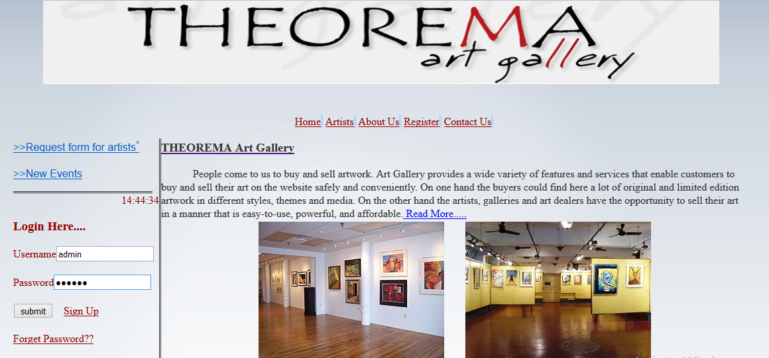

Admin Homepage:
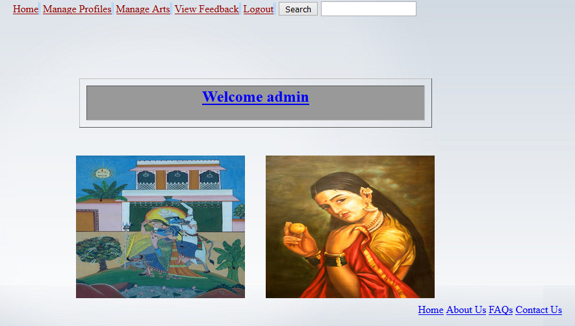

Functions of Admin:
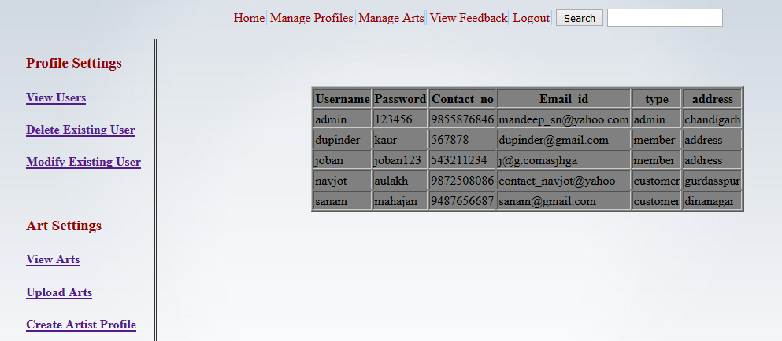

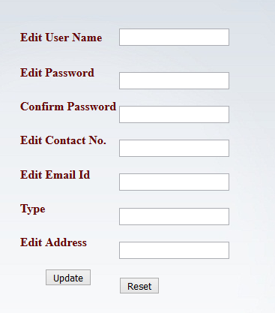

Member Homepage:
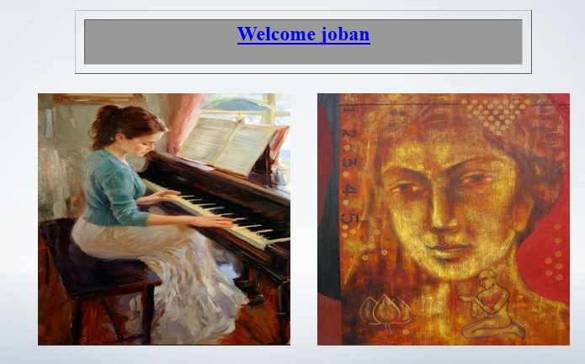

Member Change Password:
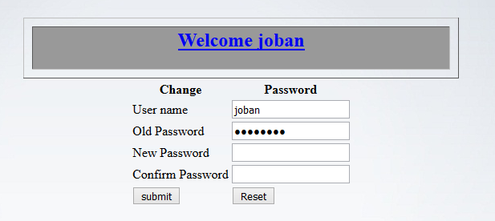

Tables:

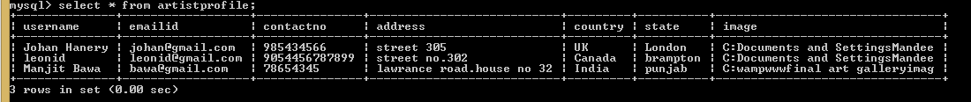

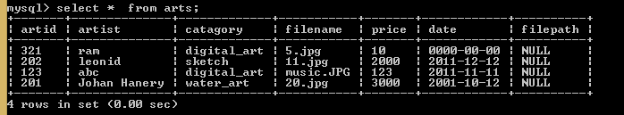

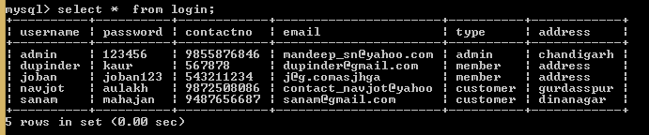

BIBLIOGRAPHY
- www.google.com
- www.w3schools.com
- www.phpbuddy.com
- www.mysql.com
- www.phpeasystep.com

